**Test Cases**

**1 ) To verify the functionality of the toggle button, check if it is working properly**

Module : Before choosing the language, check if the toggle button is working properly.

Test Case No : TC001

Priority : High

Test case Description : When selecting the source and target languages for translation, it is essential to first verify the functionality of the toggle button.

Pre-Condition : Load the translate page.

Test steps : .

1. Click on the toggle button.

Test Data : N/A

Expected Output : Toggle button can handle on or off method.

Actual Output : Toggle button can handle on or off method.

Status (Pass/ Fail) : Pass

Test Evidence :

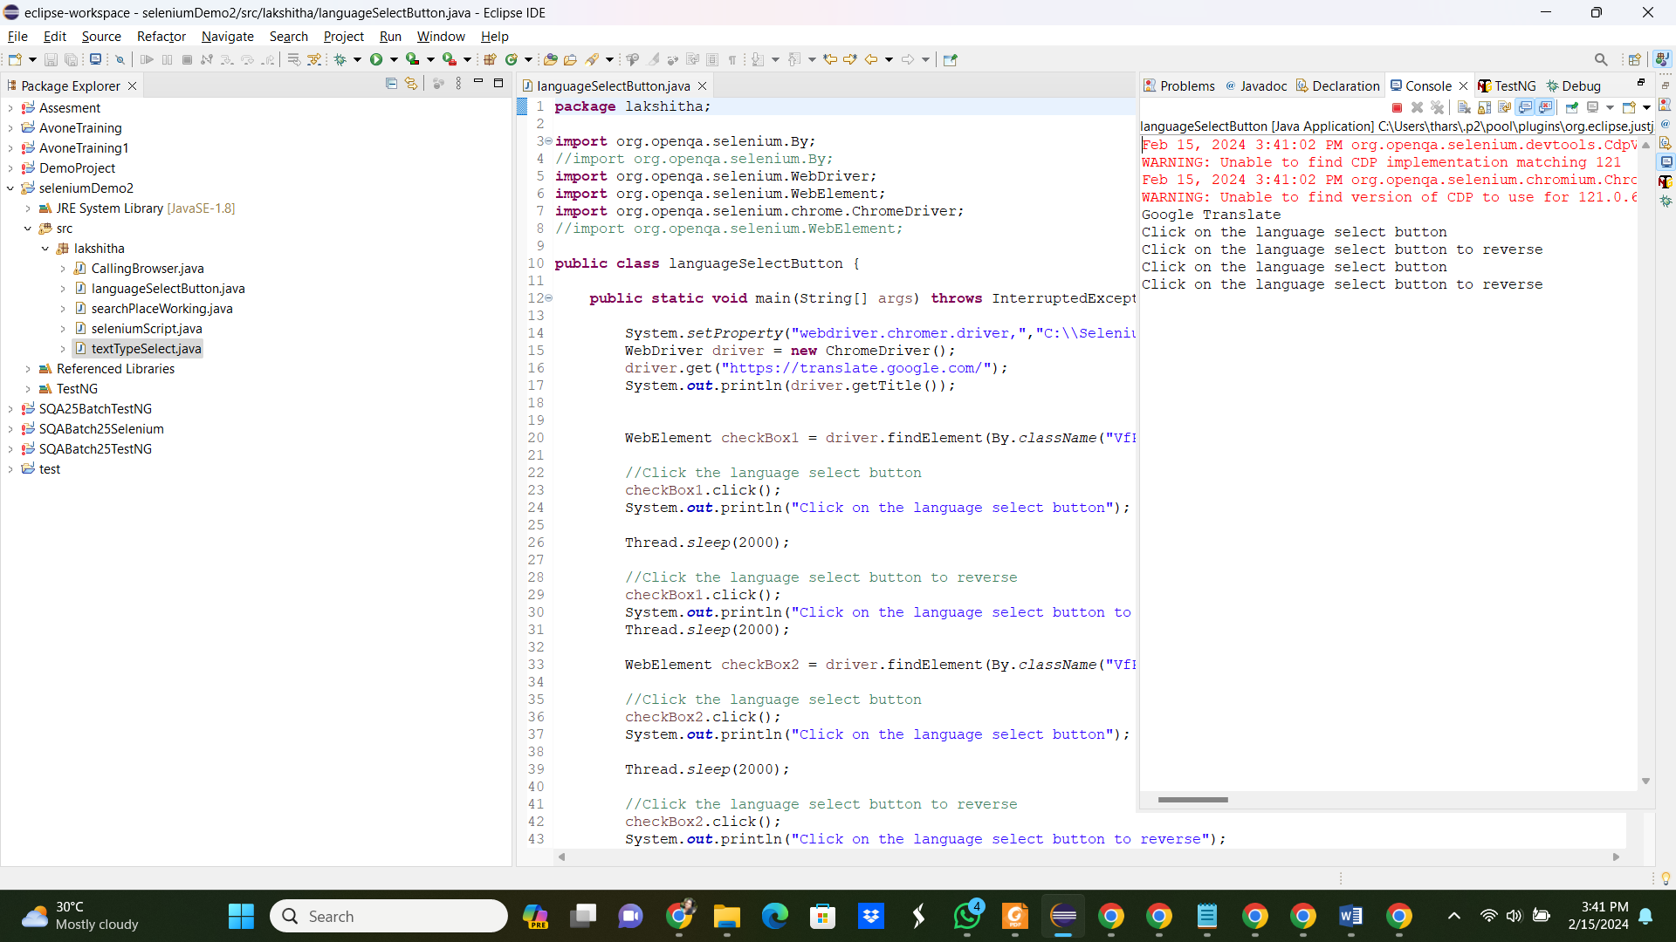

**Note: I was unable to find a unique ID to identify the element, which prevents further automation. I checked whether it have unique id, name, class name, tag name or xpath. I got class name, but when I use that it selects setting button.**

**2 . English to Tamil Translation**

Module : English to Tamil Translation

Test Case No : TC002

Priority : High

Test Case Description : Translate the English word to Tamil.

Sub test Cases :

1. To input ‘mother’, use you PC keyboard.
2. To input ‘mother’, use the translation page keyboard.
3. To input ‘mother’, use English from Input Tool Button.
4. To input ‘mother’, use English Dvorak from Input Tool Button.
5. To input ‘mother’, use English-Handwrite from Input Tool Button.

Pre- Condition :

1. Load the page.
2. From text/ image/ document/ website , choose text format.
3. Select language choose button from which to which language need to do.

Test Steps :

1. Type ‘English’ in the search language space in left hand side.
2. Select English from the option.
3. Type ‘Tamil’ in the search language space in left hand side.
4. Select tamil from the option.
5. Select input choose tool button
6. Choose English from that selection
7. Select the keyboard.
8. Input the word, ‘Mother’.

Test Data : Mother

Expected Output : Need to Translate and result should அம்மா.

Actual Output :

Status (Pass/Fail):

Test Evidence :

**3 . Tamil to English translation**

Module : English to Tamil Translation

Test Case No : TC003

Priority : High

Test Case Description : Translate the Tamil word to English.

Sub test Cases :

1. To input ‘அம்மா, use you PC keyboard.
2. To input ‘அம்மா, use the translation page keyboard.
3. To input ‘அம்மா, use vanakkam from Input Tool Button.
4. To input ‘அம்மா, use Tamil – Tamil99 Dvorak from Input Tool Button.
5. To input ‘அம்மா, use Tamil-Inscript from Input Tool Button.
6. To input ‘அம்மா, use Tamil – TYPEWRITER from Input Tool Button.
7. To input ‘அம்மா, use Tamil – ITRANS from Input Tool Button.
8. To input ‘அம்மா, use Tamil-Handwrite from Input Tool Button.

Pre- Condition :

1. Load the page.
2. From text/ image/ document/ website , choose text format.
3. Select language choose button from which to which language need to do.

Test Steps :

1. Type ‘English’ in the search language space in left hand side.
2. Select English from the option.
3. Type ‘Tamil’ in the search language space in left hand side.
4. Select tamil from the option.
5. Select input choose tool button
6. Choose English from that selection
7. Select the keyboard.
8. Input the word, ‘Mother’.

Test Data : அம்மா.

Expected Output : Need to Translate and result should mother.

Actual Output :

Status (Pass/Fail):

Test Evidence :

Appendices

Source Code

1. To verify the functionality of the toggle button, check if it is working properly.

